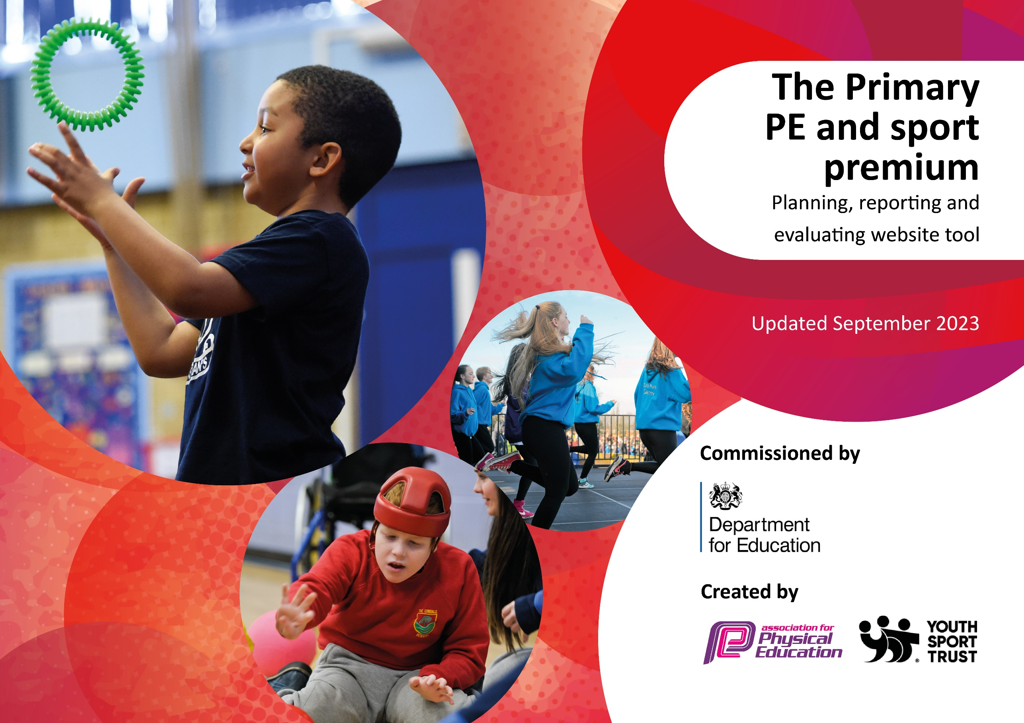

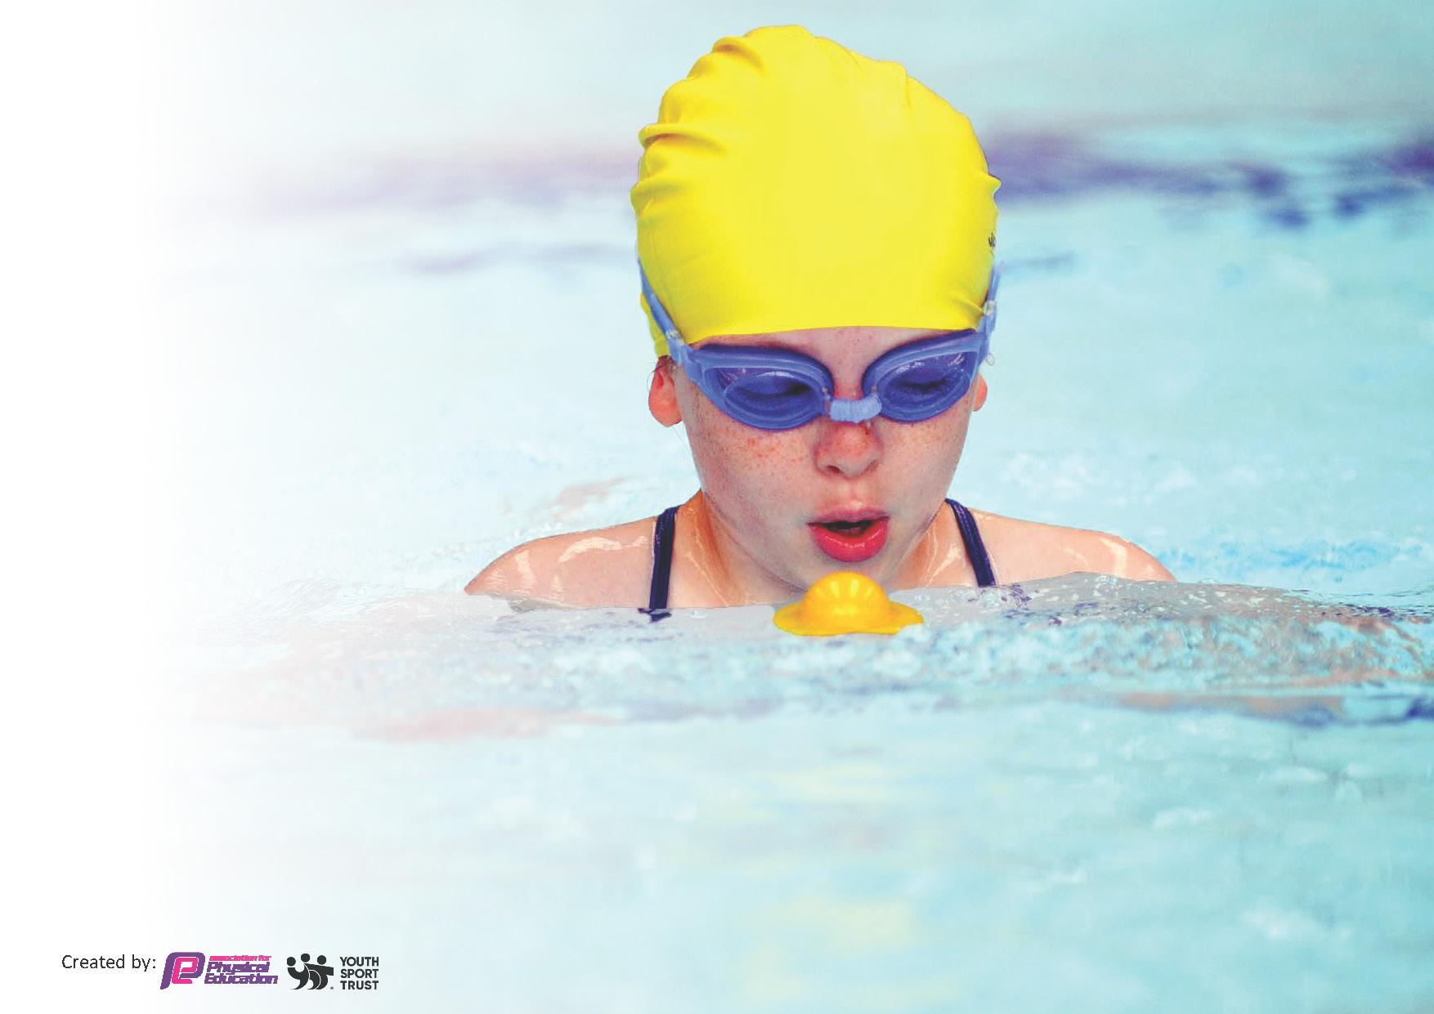
This template can be used for multiple purposes:
by:
- It enables schools to effectively plan their use of the Primary PE and sport premium
- It helps schools to meet the requirements (as set out in guidance) to publish information on their Primary PE and sport premium
- It will be an effective document to support Ofsted inspections enabling schools to evidence progress in Physical Education (PE) and evidence swimming attainment, which forms part of the PE National Curriculum. We would recommend schools consider
the Intent, Implementation and Impact of any spend, as examined within the Education Inspection Framework.

It is important that your grant is used effectively and based on school need.

Schools must use the funding to make additional and sustainable
improvements to the quality of the PE, School Sport and Physical Activity (PESSPA)
they offer. This means that you should use the Primary PE and sport premium to:

- Build capacity and capability within the school to ensure that improvements made now will benefit pupils joining the school in future years
- Develop or add to the PESSPA activities that your school already offers.

The Primary PE and sport premium should not be used to fund capital spend projects; the school’s core budget should fund these. Further detail on capital expenditure can be found in the updated Primary PE and sport premium guidance.

The Primary PE and sport premium guidance, outlines 5 key priorities that funding should be used towards. It is not

necessary that spending has to meet all the key priorities, you should select the priorities that you aim to use any funding towards.

Although completing this template is not a requirement for schools, schools are required to publish details of how they spend this funding. Schools must also outline what the impact this funding has had on pupils’ PE and sport participation and attainment and how any spending will be sustainable in the future. All funding must be spent by 31st July 2024.

The Department for Education has worked closely with the Association for Physical Education (afPE) and the Youth Sport Trust (YST) to develop this template and encourages schools to use it. This template is an effective way of meeting the reporting requirements of the Primary PE and sport premium.
Review of last year’s spend and key achievements (2022/2023)

We recommend you start by reflecting on the impact of current provision and reviewing your previous spend.

Activity/Action | Impact | Comments
To increase the physical activity of all pupils in school.  Install a climbing frame to encourage pupils to become more physically active during break and lunchtimes.  Continued support from CSSP to supplement the delivery of the PE curriculum throughout the school. To continue to help broaden PE experiences for the pupils and to support staff in the delivery of curriculum PE.  Level 5 PE qualified HLTA to over-see the delivery and planning of PE throughout the school. To maintain a consistent approach, a small group of staff deliver our school PE curriculum throughout school. Teachers continue to work closely with the PE lead to gain confidence and knowledge in delivering high quality PE sessions to children in school. | All pupils are physically active, and the climbing frame has been a great addition to our outdoor provision. Pupils' fine and gross motor skills have improved, and pupils are challenged when moving around the different areas of the structure.  Pupils continue to enjoy their PE sessions and are actively engaged in sessions. Pupils who were previously not as active or engaged have made considerable progress. Staff have also been able to use this opportunity for their own CPD, to expand on their knowledge and confidence when delivering PE.  Teachers have gained confidence in delivering quality PE lessons for our pupils. Their knowledge has also been improved and this has shown in their delivery of lessons. | To continue to look at ways in which to improve our outdoor provision for our pupils and to continue to encourage physical activity during break and lunchtimes.  To continue to buy in to CSSP and work closely with them to further enhance our pupils’ sporting experiences through the curriculum PE and through the wider school sports competitions and festivals. Staff will continue to benefit from working alongside CSSP to become better practitioners in delivering PE throughout school.  To continue with this model next year. This will ensure our PE curriculum is well planned and the teachers delivering PE can continue to offer a broad and balanced PE curriculum for all our pupils.

Key priorities and Planning
This planning template will allow schools to accurately plan their spending.

Action – what are you planning to do | Who does this action impact? | Key indicator to meet | Impacts and how sustainability will be achieved? | Cost linked to the action
Continue to improve the knowledge and confidence of staff in the delivery of PE, physical activity and school sport across the school. Employ CSSP to deliver sessions in the PE curriculum that we have identified would benefit from their specialist support.  PE courses for staff who are involved in delivering PE and school sport in school.  Purchase of the Lancashire Primary PE Passport App. This includes the PE schemes of work, assessment and access to other useful resources to support the PE delivered in school.  Level 5 PE qualified HLTA to support the delivery and planning of PE throughout the school.  To increase the physical activity of all pupils in school during break and lunchtimes with the installation of a climbing frame.  Improve the quality of play at lunch and break time. Invest in new playground equipment to support the physical activity of the pupils.  Employ Fencing Education to deliver a half term of fencing during curriculum time for our Y3&4 pupils.  Pupils to participate in the Lancs Big Sing and perform at Chorley Town Hall.  Invest in safety equipment for pupils taking part in school sport.  To cover the cost of transport to events involving a number of pupils. | Pupils continue to experience high quality PE lessons in school. Lessons are progressive and skills they learn build over time, ensuring pupils have good physical literacy.  Pupils are taught by knowledgeable teachers, who understand the skills that the children need to progress and become physically competent in all areas of the PE curriculum.  Pupils continue to benefit from a broad, progressive PE curriculum, that the Primary PE Passport supports.  Teachers continue to work closely with the PE lead to gain confidence and knowledge in delivering high quality PE sessions to children in school.  All pupils throughout school will benefit, ensuring they reach their daily activity goals.  Having access to the use of equipment during break times has encouraged more pupils to become active. This has helped improve their gross motor skills and has contributed to the daily active goals.  Pupils can experience a different sport which they may not have tried before.  For most pupils, this was a new experience. It was a great opportunity to experience something they had not tried before.  Pupils can now take part in the CSSP Hockey competition as they have the appropriate safety equipment.  36 our KS2 pupils were able to take part in the district final of the indoor athletics | Key indicator 1: Increased confidence, knowledge and skills of all staff in teaching PE and sport.  Key indicator 2: Engagement of all pupils in regular physical activity.  Key indicator 1: Increased confidence, knowledge and skills of all staff in teaching PE and sport.  Key indicator 1: Increased confidence, knowledge and skills of all staff in teaching PE and sport.  Key indicator 2: Engagement of all pupils in regular physical activity.  Key indicator 1: Increased confidence, knowledge and skills of all staff in teaching PE and sport.  Key indicator 2: Engagement of all pupils in regular physical activity.  Key indicator 3: The profile of PE and sport is raised across the school as a tool for whole school improvement.  Key indicator 2: Engagement of all pupils in regular physical activity.  Key indicator 2: Engagement of all pupils in regular physical activity.  Key indicator 4: Broader experience of a range of sports and activities offered to all pupils.  Key indicator 4: Broader experience of a range of sports and activities offered to all pupils.  Key indicator 5: Increased participation in competitive sport.  Key indicator 5: Increased participation in competitive sport. | Increased confidence and knowledge amongst staff who deliver PE. This has been supported by regular evaluations by the PE Lead. Pupils are taught high quality PE lessons because of this. Moving forward, staff will be equipped to continue to be able to deliver high quality PE lessons for all pupils.  Staff knowledge and confidence is increased, enabling them to continue their delivery of high-quality PE to all pupils in school.  Progressive lesson plans for all units of work delivered throughout the PE curriculum.  This will provide continuity as pupils progress through school, building on previous skills taught.  Having a PE specialist in place ensures that the delivery of PE lessons throughout school are well planned and progressive for all pupils. Knowledge gained over the years can be shared with other staff to ensure the continued delivery of high-quality PE lessons for all our pupils.  This has been an excellent addition to our outdoor provision for all pupils in school. It has helped to enhance all pupils' physical activity during break and lunchtimes. Pupils' fine and gross motor skills have improved, and pupils are challenged when moving around the different areas of the structure.  In offering our pupils access to a wider range of equipment during break and lunchtimes, we can continue to support our less active pupils.  60 pupils have now experienced fencing and gained insight into this sport. They have learnt new skills associated with the sport, and this encouraged some pupils to enroll in the extra-curricular fencing club.  The pupils really enjoyed this event, as it was a new experience. It was good for pupils’ mental health and self-esteem. They enjoyed learning the different songs and were inspired by the singing teacher who came to school for an afternoon to promote the Lancs Big Sing. Performing alongside other children from different schools was also a great experience for our pupils.  Pupils can compete against other children and learn many skills, including learning to win and lose, respecting others and fair play. This helps our pupils become more resilient. | £3,258.00  £388.00  £1,797.00  (3 year offer)  £7,250.00  £4,000.00  £415.00  £480.00  £390.00  £21.00  £300.00

Key achievements 2023-2024
This template will be completed at the end of the academic year and will showcase the key achievements schools have made with their Primary PE and sport premium spending.

Activity/Action | Impact | Comments
Increase in extra-curricular clubs offered to pupils.  Exploring new activities for pupils to engage in.  Sporting successes at Chorley District level.  (Indoor Athletics, Hi 5, Hockey, Tag Rugby, Basketball)  Increased opportunities in sporting festivals and competitions for our SEND pupils, resulting in success at district level which lead to regional competitions. | Increased participation in clubs. Pupils who would not usually engage are now attending.  Pupils have been able to access sports they have not experienced before.  Pupils have experienced high level competitive sport and the rewards of success. Through this, they have also learned life skills such as sportsmanship, respect and teamwork.  These experiences have given our pupils more confidence in their abilities. It has also helped them engage better during PE lessons and get excited about sport and physical activity, which they may not have been previously. | Ensuring we have more staff to deliver a wider range of activities for pupils has enabled more pupils to attend.  Pupils have gained confidence and been given new opportunities.  Pupils have been able to transfer the skills learnt in PE lessons and apply them in competitive sports.  It has been lovely to see pupils embrace opportunities given to them. To see confidence and self-esteem increase and to be more engaged in physical activity.

Swimming Data
Meeting National Curriculum requirements for swimming and water safety.
Priority should always be given to ensuring that pupils can perform safe self-rescue even if they do not fully meet the first two requirements of the National Curriculum programme of study

Question | Stats: | Further context  Relative to local challenges
What percentage of your current Year 6 cohort can swim competently, confidently and proficiently over a distance of at least 25 metres? | 94%
What percentage of your current Year 6 cohort can use a range of strokes effectively [for example, front crawl, backstroke, and breaststroke]? | 90%

What percentage of your current Year 6 cohort are able to perform safe self-rescue in different water-based situations? | 94%
If your schools swimming data is below national expectation, you can choose to use the Primary PE and sport premium to provide additional top-up sessions for those pupils that did not meet National Curriculum  requirements after the completion of core lessons. Have you done this? | No
Have you provided CPD to improve the knowledge and confidence of staff to be able to teach swimming and water safety? | No

Signed off by:

Head Teacher: | Claire Procter
Subject Leader or the individual responsible for the Primary PE and sport premium: | Becky Chadwick
Governor: | Hannah Humphris
Date: | June 2024

